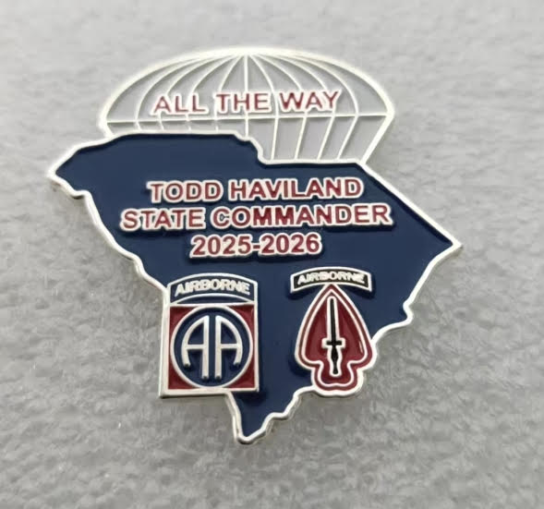
2025- 2026
COMMUNITY SERVICE REPORT FORM FOR INDIVIDUAL COMRADES
(Including Post Auxiliaries) Complete all highlighted items please!
(Revised 12/14/2025)

Post/Auxiliary Number: _______ District Number ____

This form is for individual comrades to report their Community Service activities to their Post Commander. The Commander’s designated reporting official will consolidate these reports and submit ONLINE monthly Community Service reports using the Department website https://vfwsc.org

DATE OF ACTIVITY___________

SELECT A PROGRAM (Circle your choice) (See definitions of each category below):
Community service Americanism/ Citizen Education Youth Activities Safety Veterans and Military Support Voice of Democracy/Patriots Pen Teacher of Year/ Scouting Program
TOTAL HOURS___ TOTAL MILES____ TOTAL MEMBERS_____ $ DONATED______
(example: 12 Total Hours, 24 miles, 4 Members (each performed 3 hours service)
(Safety example: 1 person gave briefing for 5 minutes/ enter 1 comrade/ .08 hrs )
Description of activity and how it meets the criteria for your chosen program in the categories listed below
________________________________________________________________________________________________________________________________________________________________________________________________________________________________________________________________________________________________________________________________________________________________________________________________________________________________________________________________________________________________________
__________________________________________________________________________________________________________________________
(use reverse side of this form for more space)

Categories of Community Service:
COMMUNITY SERVICE includes any activities within your community which help to benefit the community, church, school, parks, recycling, neighborhood cleanings, etc. while representing the VFW
AID TO OTHERS is self-explanatory. Taking a hot meal to a veteran who can't get out is an example.
AMERICANISM/CITIZEN EDUCATION - teach someone about flag etiquette, military service, etc.
YOUTH PROGRAMS include the annual Voice of Democracy, Patriot's Pen, Scout of the Year Program, etc.
YOUTH ACTIVITIES - Posts and Auxiliaries are encouraged to provide youth programs within the community such as Athletics, Scouting, School Assemblies, Veterans in the classroom, Contests, Recognition, etc.
SAFETY - Pedestrian, Drug Awareness, Recreational, Highway, Home/Fire, etc.
VETERANS & MILITARY SERVICE - Any support given to a unit, an individual family member, a veteran’s widow, military or graveside ceremonies, welcome home, upLink, Unmet Needs, USO, Tunnels 2 Towers, DAV donations

